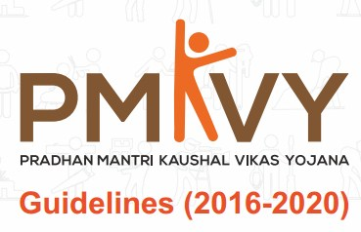
Introduction
The Union Cabinet had approved India’s largest Skill Certification Scheme, Pradhan Mantri Kaushal Vikas Yojana (PMKVY), on 20 March, 2015. The Scheme was subsequently launched on 15 July, 2015, on the occasion of World Youth Skills Day by Honorable Prime Minister, Shri Narendra Modi. PMKVY is implemented by National Skills Development Corporation (NSDC) under the guidance of the Ministry of Skill Development and Entrepreneurship (MSDE). With a vision of a Skilled India, MSDE aims to skill India on a large scale with speed and high standards. PMKVY is the flagship scheme that is driving towards greater realisation of this vision. Owing to the its successful first year of implementation, the Union Cabinet has approved the Scheme for another four years (2016-2020) to impart skilling to 10 million youth of the country. This booklet contains the various Guidelines under the Scheme that participating agencies need to abide by. The Guidelines mentioned in this booklet have the approval of the PMKVY Steering Committee and are effective from 15 July, 2016. These Guidelines include the following:
Base Costs
The per candidate base costs for different sectors will be either INR 28.9, INR 34.7 or INR 40.4 as per the trainings in various job roles/sectors defined in the three different categories defined in the SOP document Per hour Base Costs for Trades/Sectors. Costs will be updated as per the Common Norms in case of any changes.
Payout Milestones
Tranches | % of Total Cost | Output Parameters
1 | 30% | On commencement of the training batch against validated candidates
2 | 50% | On successful certification of the trainees
3 | 20% | Outcome based on placements

Boarding and Lodging Payouts
Category of District | Amount
X Category Districts per day per trainee | INR 300/-
Y Category Districts per day per trainee | INR 250/-
Z Category Districts per day per trainee INR 200 (every District that is NOT X or Y) | INR 200/-
#The districts falling under X and Y categories are subject defined by DoPT, Government of India.
Post Placement Support
In order to enable the newly skilled persons to settle into their new jobs/vocations, post placement support would be provided directly to the candidates at the rate of INR 1450 per month for the duration
Post Placement Support @ INR 1450 per month | Men | Women
Placement within the District of Domicile | 1 months | 2 months
Placement outside the District of Domicile | 2 months | 3 months

Conveyance Support
Upon successful completion and certification of non-residential skill training programmes, all women candidates and PWD will be provided an allowance for expenses incurred in travelling to and from the TC
Conveyance Support per month | Amount (in INR)
1. Training Centre within the District of Domicile | 1000/-
2. Training Centre outside the District of Domicile | 1500/-

Target Allocation Methodology
The targets may be allocated to the TC for a period of 6 or 12 months on the basis of the grading of centres; the capacity of centres with a provision for periodic review (Compliance and Performance) as per the Monitoring Guidelines of PMKVY. NSDC proposes the below methodology for allocating the targets to various TCs/TPs approved (or yet to be approved) under PMKVY 2016-20:
- Targets would be allocated for three months with monthly compliance review and quarterly performance review.
- Usable area greater than 3000 sq. ft. is preferable however not a mandatory condition.
- TCs will be assessed and verified as per the Monitoring Guidelines of PMKVY
- Targets to be estimated by NSDC PMU basis centre capacity and to be allocated directly to the centers through SDMS.
- Centre capacity would depend upon number of PMKVY classrooms; number of Job roles/SSCs affiliated to; number of course hours in a job role (approximately 200 hours), and number of certified trainers
- Target allocation methodology is based upon the following assumptions: 
- Number of Operating hours in a day: 8 hours 
- Batch operational hours in a day: 4 hours (2 hours each for theory and practical) 
- Job role-wise number of classrooms and labs, whichever is less 
- Total number of hours for a job role as prescribed by the SSC

Case Scenarios in First Quarter
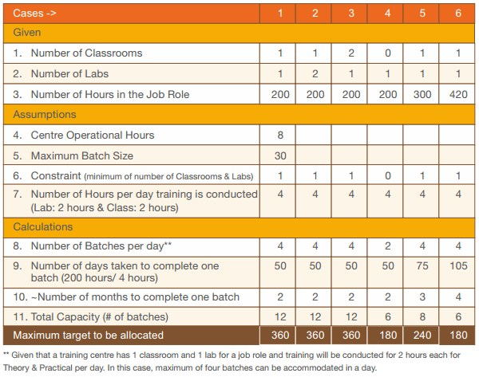
Pass Percentage for a QP basis NSQF levels
NSQF Level | Percentage required for Passing a QP
1,2,3 | 50 %
4 & above | 70 %

Fees to be Paid by the Training Centre
Application Registration Fee
A one-time Application Registration Fee of INR 10,000 shall be charged from the parent organization. This fee shall be non-refundable.
Accreditation Fee
a. Any TC applying for accreditation has to pay an Accreditation Fee in order to complete the Self Assessment request. Provision of a payment gateway for facilitating online fee payment shall be provided, details of which shall be provided at the NSDC website (www.nsdcindia.org).
b. It is to be noted that the TC has to pay the Accreditation Fee for each job role. The total fee shall be an annual cost. The fee shall be non-refundable.
c. The following structure of Accreditation Fee is applicable to all the TCs that apply for accreditation: i. A Base Cost of INR 20,000. This amount includes the following components:
A Base Cost of INR 20,000. This amount includes the following components:
S. No | Fee description | Fees (Amount Remarks in INR) | Remarks
1 | Annual Accreditation | 12,000 | Cost pertaining to the on-site inspection of the TC
2 | Annual Continuous Monitoring Fee | 8000 | Cost pertaining to Annual Continuous Monitoring that includes surprise visits (if any) and monitoring through various other means, such as Call Validation, Management Information System (MIS) data, and analysis of online reports submitted by the TC.
# Incremental Cost of INR 1000 for each job role, over and above the Base Cost.

